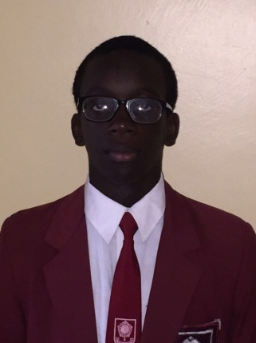
Name: Boniface Omina
School: Lenana School
Age: 17
Mobile: 0725991480
E-mail: ominaboniface@gmail.com

2ND MENTORING YOUNG ENGINEERS
SEMINAR
27TH APRIL 2016

The third day of the engineering seminar began in the most exciting way. I had not quite expected events to turn out as they did, but I presume that whenever AKAD is involved, we should prepare for the unexpected. I have had the greatest experience of all the days and discovered new-found abilities in myself.
The day’s events were kicked off by the learning of crucial martial arts techniques from Dr. or if I may say Sensei Julius Weche and David Muruwa. It is very rare to acquire information on self-defense and actually have the person there demonstrating the techniques to you. One of the fundamental areas that people do not consider is their responsiveness to danger. Anything can happen, anywhere and anytime that can endanger ones safety. How we choose to approach the situation can determine whether we walk out of the room alive or in a body bag. We have different options to consider; escape, hide or attack. All are effective in dealing with dangerous situations, such as a terrorist attack. We should always be observant of our surroundings and keen to any potential threats in order to ensure our safety and that of others.
We received some interesting tips from Eric Kimonyi, an AKAD peer mentor and a student at the Technical University of Kenya. We were shown the appropriate way of shaking someone’s hand when presenting yourself to them for the first time. This falls squarely under personal branding and the image that we put forward to the newly met person. He also spoke about the opportunities that AKAD has created for him. From attending conferences where he meets great names in the industry, to mentoring young students in high school, Eric has done it all through AKAD. One of the reasons he has been able to achieve so much is that he saw an opportunity to market himself and seized it. Opportunity dances with those on the floor, and if we are not able to take up the challenge then we will be left behind.
We had the most interesting conversation about the youth and engineering with Mr. Teddy Warria. He challenged us as the youth on certain areas that we never paid much attention to prior to our time at the seminar. There are technological innovations that we use every single day but don’t know one bit about who started them and why. We are so fascinated by these applications and websites but we don’t care to figure out how they came to be and how we too can create such innovations to solve the many problems that we encounter each day. Africa seems to be rising in the innovators perspective, but is it really moving forward? We are very able to invest in our own businesses in our own country yet it is the foreigners who come to our country to start these businesses and thereafter employ us to work for them. If we ourselves can’t bring change to our society then who is to blame for the high unemployment rates in the nation?
I had the opportunity of engaging with Mr. Amy Wanyama for a second time, after previously meeting him during my first AKAD conversations at MOW club. He spoke about negotiation skills and how we are able to sell ourselves within the first few moments that we meet a potential business associate or employer. The kinds of abilities and interests that we have determine whether the person who we are presenting our ideas to would want to interact with us further. When in need of a certain provision from the business associate, it is important to give him something that he requires first. This is being in need, but also creating a demand. Any meaningful negotiation should be result-oriented; in that you are looking at the end result and how you are going to benefit from it.
The day was put to a close by inspiring words from Engineer Fatuma Mohammed, who talked quite a lot about soft skills and having the emotional intelligence to be aware who you are and what motivates you in life. In today’s world, and employer will not only look at what you are good at technically but also your communication skills, adaptability and teamwork skills. The consequences of lacking these soft skills is that you will lack effectiveness in the field that you are working in and also limit the growth of your opportunities of moving up in your field. I have received a truck-load of information about a lot of things that I have never considered to be important and I aim to use this information and networks to be able to aid me in pursuing my career in software engineering. I plan to work closely with Mr. Warria and Africa’s Talking to be able to see what I can contribute to the society and receive mentorship on Information Technology. Once again, I am very thankful to AKAD for organizing this seminar on engineering mentorship and to Dr. Weche and Eric Kimonyi for believing in me and granting me this wonderful opportunity and amazing experience.
