NAME: BONIFACE OMINA
AGE: 17
SCHOOL: LENANA SCHOOL
MOBILE: 0725991480
EMAIL: ominaboniface@gmail.com

20TH AKAD CAREERS SEMINAR
THEME: LEADERSHIP AND YOUTHPRENEURSHIP-
SUCCESS AND SOLUTIONS TO RADICALISATION IN SCHOOLS

24TH-26TH AUGUST 2016

At this day and age, the adults in society are constantly encouraging the youth to wake up and smell their reality, because soon enough there won’t be time to make a change. Nevertheless, it is much more effective if the wake-up call was to come from the youth themselves through peer mentors. So that is exactly what this seminar was about; the youth being able to empower each other as we are get help from our mentors on different areas and problems which we face today.
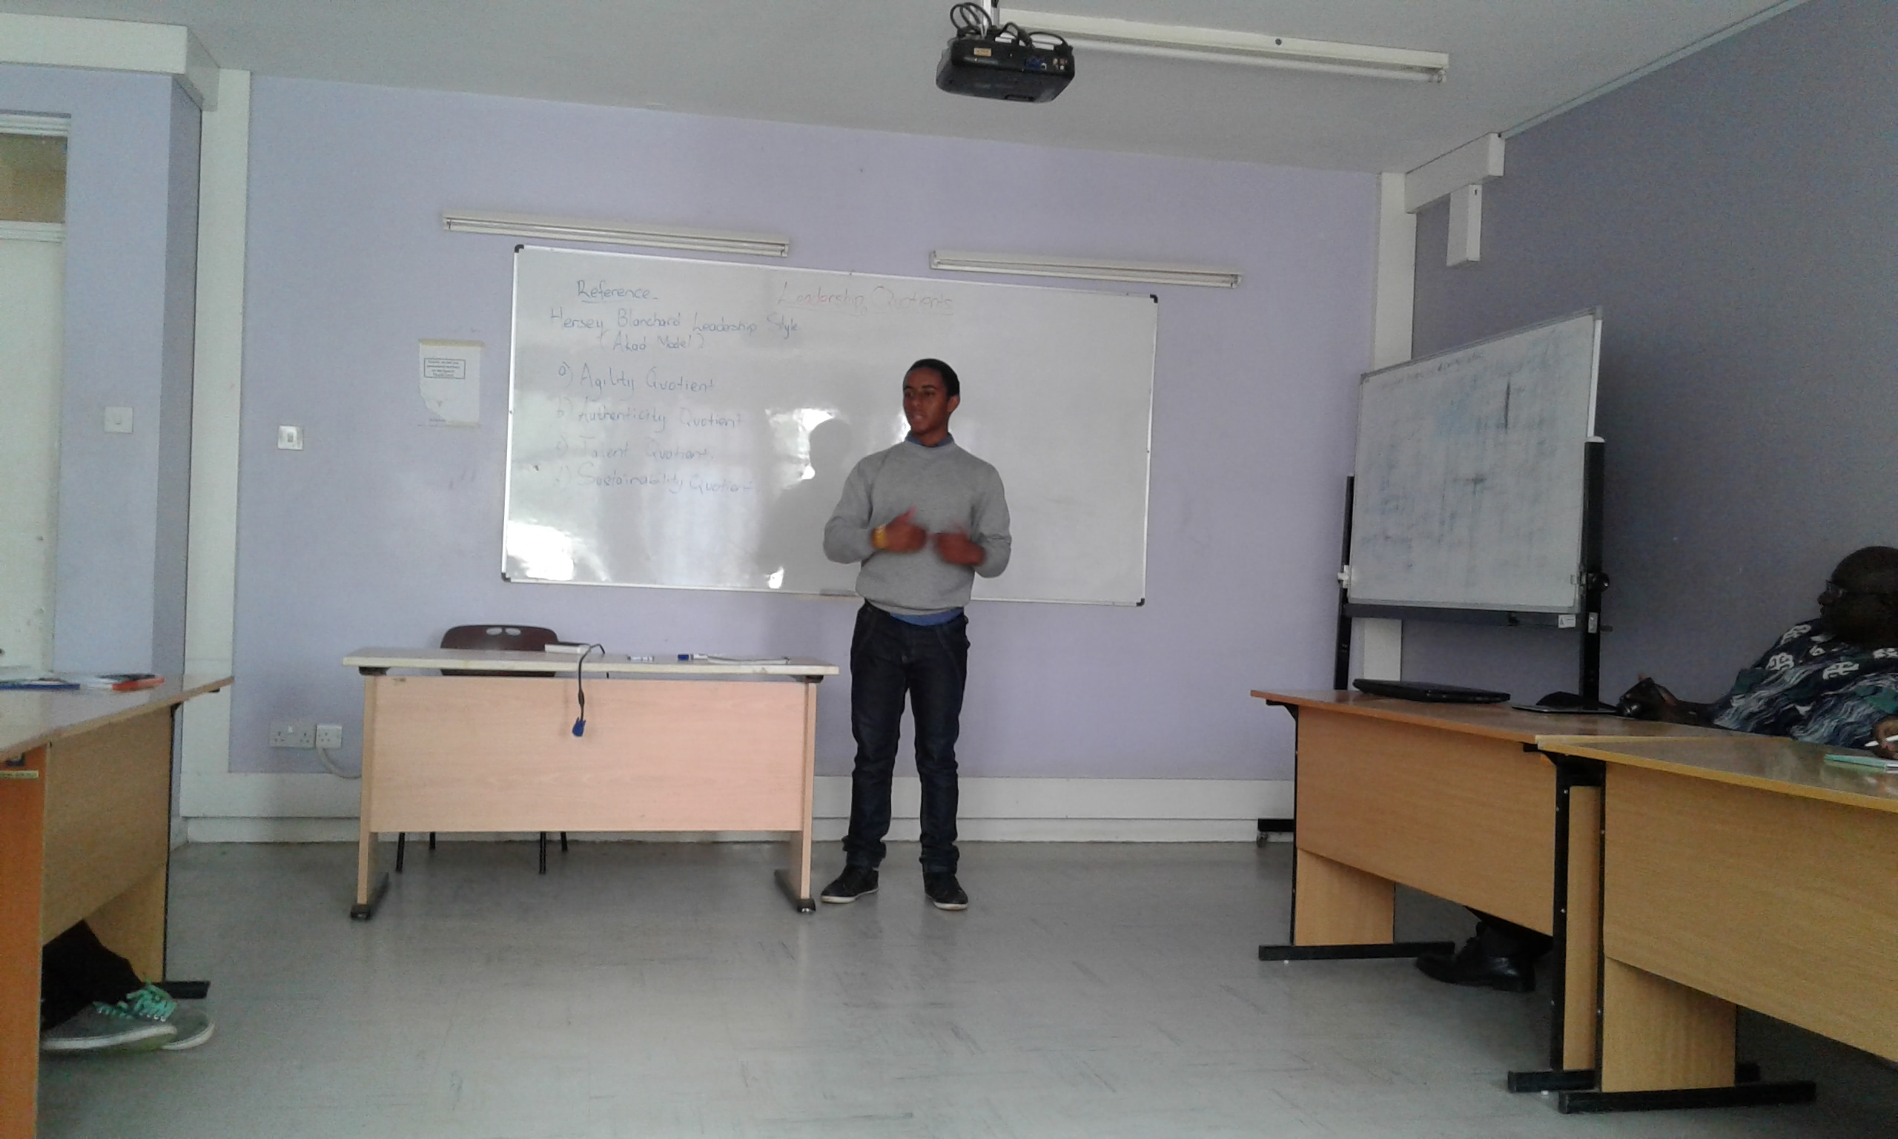
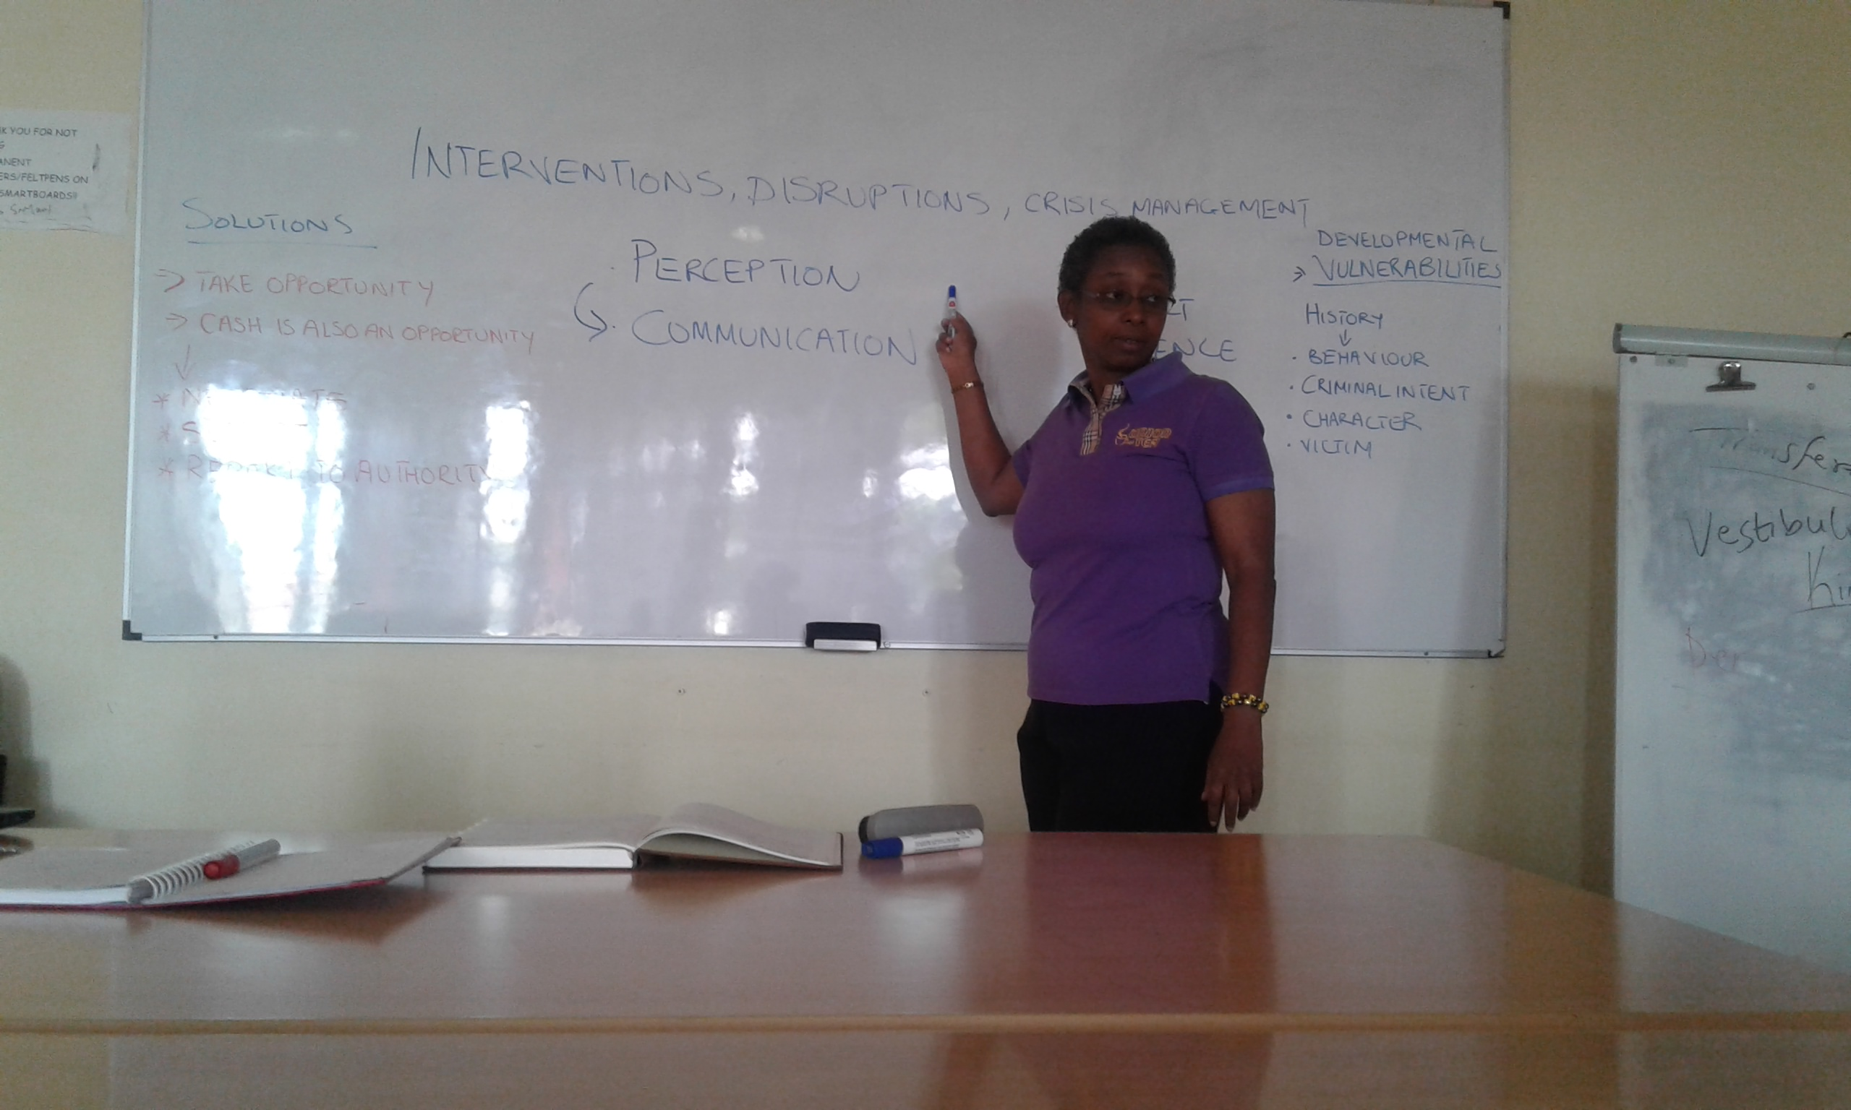
One major area emphasized by our peer mentor, Eric Fairweather, is the topic on leadership quotients including the agility, authenticity, talent and sustainability quotients. On agility he talked about the ability of a person to think higher and be more flexible and dynamic. Being able to think on the spot and come up with a quick solution to a problem. This would require a high level of communication skills and articulation to be able to lead people towards your vision. He explained the authenticity quotient as a leader’s originality; who the person is and what they can bring to the table. He emphasized on a leader’s ability to tackle a situation while keeping his values in mind and standing firm.
Eric Fairweather,
Peer mentor
Availing one’s self for a mentorship talk is one thing, but really understanding the need for mentorship is fundamental for growth during mentoring. Mrs. Rosemary Wambui took us through the mentorship process, from Directing to Coaching all the way to Delegating. A mentee would start off from the directing stage, where the mentor shows the mentee what to do and how to do it. Then as the mentee moves through the different levels he is required to learn how to be independent from the mentor as his responsibilities grow. A mentee’s attitude is the key determiner of his success. He also has to be committed, be able to take initiative and be hungry for growth.
Rosemary Wambui,
AKAD Associate
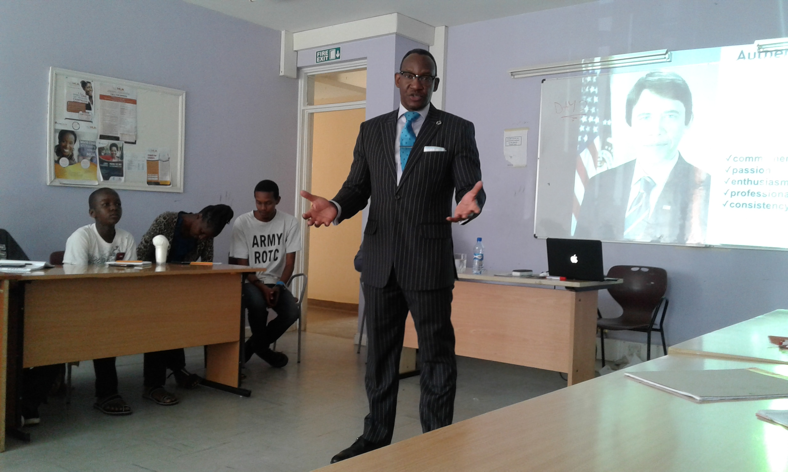
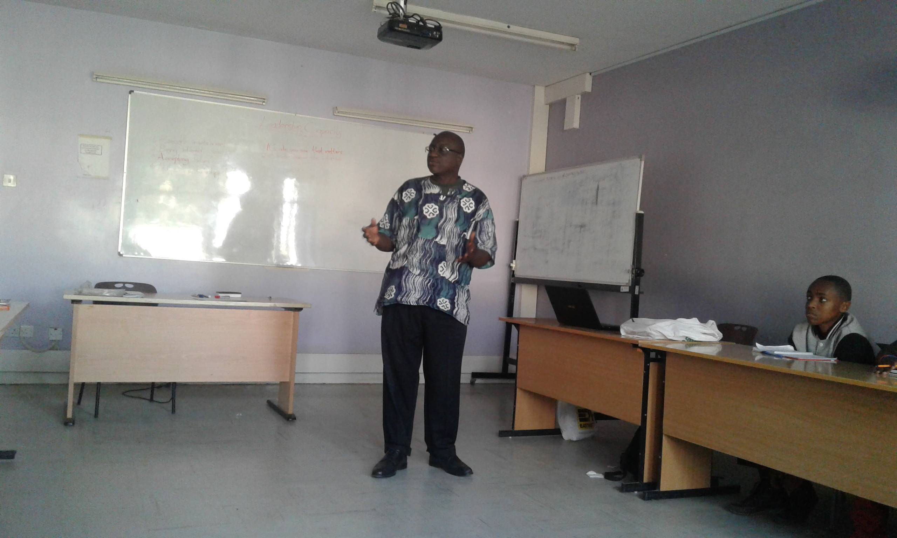
The second day was very much as eventful, with a few pointers on personal branding from Derek Bbanga. Personal branding depends on four important entities: Knowledge, Attitude, Skills and Habits. By developing and improving in all these areas, one builds an image for themselves, their brand. Constantly evolving from your brand is an important factor in order to remain relevant to society. This is known as ‘Brand Evolution’ and positive rebranding is important. Mr. Bbanga also spoke about the importance of public speaking and building on communication skills. In any job market in the present day, specific communication skills are key and considered by employers. Speaking to people with energy and enthusiasm builds a one-on-one connection with listeners therefore passing a message across more effectively.
Derek Bbanga,
Personal Branding Consultant
A topic that is not quite understood by the youth is violent extremism and radicalization. With all the recent cases of student killings in schools and universities, the cause of all this is not understood. These incidents all stem from a person’s mindset; how they are conditioned to think and what runs through their mind before engaging in such activities. In order for one to be able to deal with these issues, he/she must know themself and know who their team is or whom they identify themselves with. One must keep in mind their values and make sure they are in line with their expectations.
Dr. Julius Weche, CEO AKAD Africa
We were taken through an in-depth course on financial literacy; a fundamental skill for any business and lack of it is the major reason why businesses fail. We were given tips on coming up with a budget, managing cash flow and a layout for a balance sheet. Dr. Weche also taught on negotiation tactics, and to always keeping interests in mind, both yours and others. If your interests are not coinciding with the interests of others, one should be willing to concede something in order to benefit in the long run. If not, one should be a distributive negotiator and increase his chance of success by making the ‘pie’ larger and increasing the other person’s benefit at the end.
Getting such a platform where we as the youth get to interact with each other, share our stories and find common ground to be able to empower each other is amazing. The team-building games from Angaza Coaching helped us get to know each other’s strengths and weaknesses and improved our ability to work together. We found out some things about ourselves that we never knew. We learnt how to relate with people who are complete strangers to us and not judge them before getting to know them. Angaza’s Mercy Kamau taught us the importance of reading people’s behavior and body language since a large percentage of a person’s thoughts and emotions are communicated non-verbally. We also learn how to deal with a terrorist and a few self-defense lessons.
Team building games by Angaza Coaching
This seminar really opened my mind to how many people out there have the same dreams and aspirations similar to mine. I was able to network with people who are interested in software engineering, coding, community service and helping the society. Through this we were able to start an initiative known as the ‘Young Alliance Movement’ or ‘YA Movement’. It is based on us as the youth empowering each other, helping one other with our individual goals that we all share. It was very interesting to be able to build a connection with each other and after only knowing each other for three days, it feels like a lifetime of socializing. I will use what I have learnt this day to get help from my peers on my endeavors and at the same time be able to use the different skills my peers have to reaching a much bigger goal and causing the greatest change possible. Once again I give great thanks to AKAD Education Group for organizing this event and the Management University of Africa for hosting us in the premises.

