NAME: BONIFACE OMINA
AGE: 18
MOBILE: 0725991480
EMAIL: ominaboniface@gmail.com
FACEBOOK: Bonny B Omina

LINKEDIN: Boniface Omina

HALF TERM HOLIDAY MENTORSHIP DAY
Saturday 24th June 2017
Once again I was privileged to join AKAD Education Group for a mentorship day which was the highlight of my half term break. For a good part of Term Two AKAD has engaged with Lenana School students every weekend, introducing them to the rigors of mentorship and fundamental academic and career planning. Therefore this event held at The Ministry Of Works Club in South C was a chance for the Lenana School mentees to engage with AKAD further.
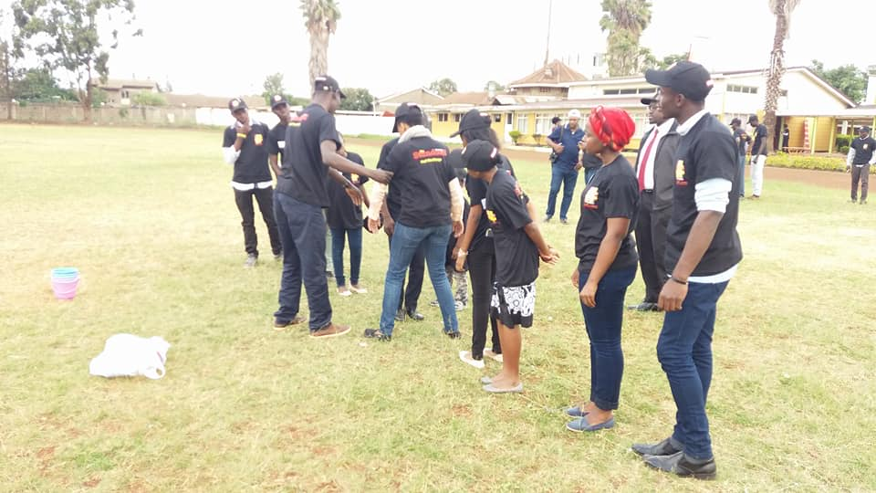
The morning activities, led by the Angaza Team held a lot of learning opportunities. One specific game called Traffic Jam required a strategy similar to that of a chess game in figuring out the puzzle. One fundamental lesson I picked up is to face your problem in order to figure out the solution. One should not be afraid to fail or make a mistake because it is through that that a solution comes about. The morning hours also allowed me to practice my public relations as I received parents and new mentees at the entrance and linked them to the registration desk. I noticed that simple interactions are networking opportunities because you never know whose hand you are shaking and what doors could be opened from that one firm handshake.
Teambuilding activities in the morning
The next session, which was done by Mrs. Rosemary Wambui, was the most interesting given that I have a lot of interest in Public Speaking. Rosemary talked about using humor in public speaking, something I had never considered to be important. Humor helps to keep your audience active and attentive as you speak. She also mentioned that it is important to know your audience so as not to say anything offensive and having a generally simple and interesting presentation. This session was very beneficial to me as all the information given will aid me in my future presentation going into the second half of Term Two and beyond that.
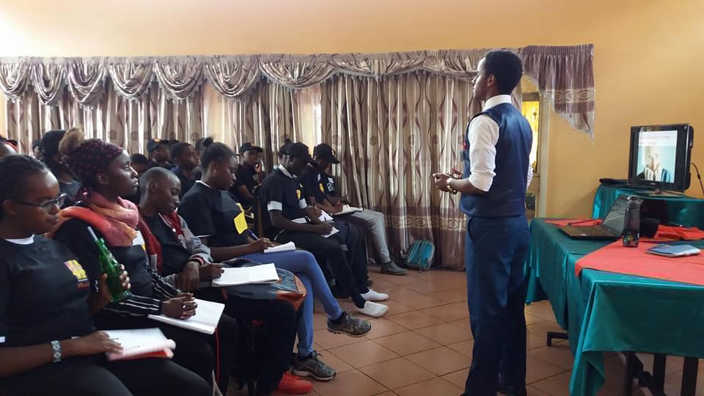
For one who has previously sat in Dr.Weche’s negotiation sessions, I knew this one would not disappoint. Despite having learnt about negotiation from him before, I still carried home something new. He talked about something called Post Settlement Settlements (POSS). Once a negotiation is done and both parties agree on a matter, there are additional services that one can negotiate for. A good example was the negotiation between AKAD and Standard Media Group where they negotiated further and we were able to be given t-shirts, caps and pens. Another new thing I learn was Cost Benefit Evaluation, which is analyzing just how much something is worth your time. This is something very important in life because time is one commodity we cannot afford to waste. If you are doing something that will not affect you in the next five years then it’s a waste of time. One should ask themselves each day whether they are utilizing their 86,400 seconds to the fullest.
2 Eric Fairweather speaking about communication
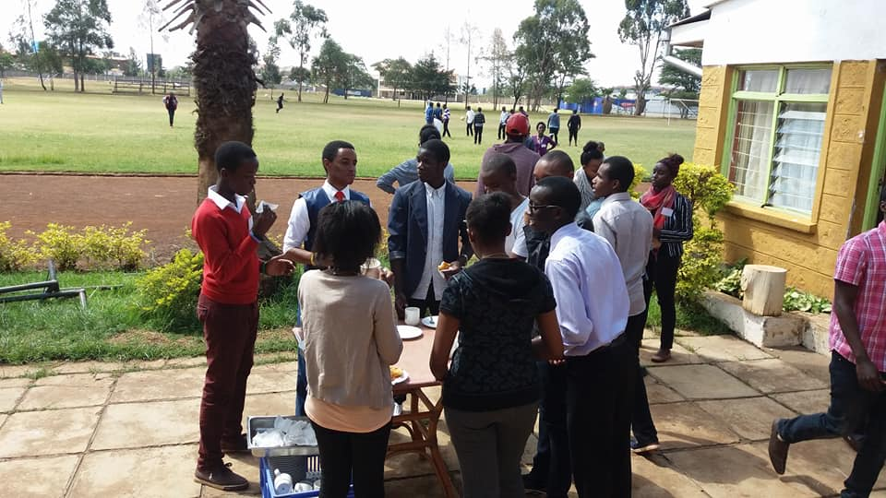
We had an informative session by Eric Fairweather who spoke about communication in leadership. One evident fact was that he was dressed to kill; that being an important aspect of communication. Like it or not people will judge you by what you wear and treat you just the same hence it is wise to dress according to what you wish to communicate. Brand representation is something that AKAD has stressed on time and time again and being able to communicate your ideas as you network with people, beginning with how you dress. The AKAD mentees were given a chance to pitch ideas to our Standard Media sponsors regarding starting a TV show that is centered on AKAD’s capacity building in academics and careers. A lot of very interesting ideas were put forward and with proper follow up, this could open up doors for the AKAD team.
Walking home from any AKAD event has someone very thoughtful. It feels as though you have received a new kind of inspiration and you are left asking yourself, “so what now?” Networking is always a beneficial part of this mentorship and I believe my networks built with Standard Media Group will help me in my media endeavors regarding my YouTube channel. It had never occurred to me that one day we might have a mentee who is deaf and this got me thinking about learning sign language. Many people will be thrilled to learn French, Spanish or German but hardly sign language. I plan to look into this and taking it up seriously. I once again thank AKAD Education Group for its mentorship and for its engagement with Lenana School.
Netwroking sessions over tea

