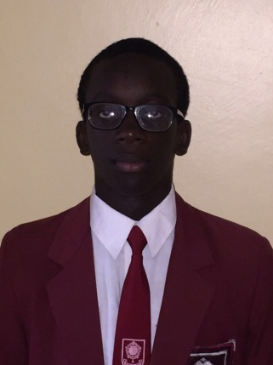
Name: Boniface Omina
Age: 17
School: Lenana School
Mobile: 0725991480
E-mail: ominaboniface@gmail.com

2ND MENTORING YOUNG ENGINEERS
SEMINAR
26TH APRIL 2016

After the amazing experience I had on my first day of engineer mentorship, I could not dare miss out on yet another opportunity of learning and engaging with great minds. The second day was destined to be my most promising since I would get to interact with a member of an organization that deals with software and computer engineering. This is the field where I am to base my engineering career on and I was eager to learn as much as I could about the course.
The day was kicked off by some interactive activities and games whose core focus was on teamwork and concentration skills. Soon after, the seminar began. The first to the stage was the lively and well-spoken Eng. Chief Andrew Okal, and alumnus of Alliance High School. He took us through his preparation for engineering at a personal level; where he shared his school experiences through primary school all the way to his university years at JKUAT (Jomo Kenyatta University of Agriculture and Technology).
Eng. Chief Andrew spoke a lot about the foundational stage in life, high school. When we enter high school, we meet a whole different world. A whole new jungle full of different personalities from around the country. Through our interactions with our fellow students we are influenced both in our social and professional lives. Whether it is our core values and morals or our career aspirations; they are all built up in those four or so years we spend in high school. In addition, the type of company we keep greatly shapes our character and behaviors that we develop. In all the key stages of life, hardwork and discipline are key values to have. To prepare the mind for careers in engineering, we should work towards knowing why things are done in a certain order rather than knowing how they are done, to be the manager and not the employee.
The climax of the day in my opinion was the inspiring talk given my Mr. Zebedeo Nyamboga, the Technology Presales Manager at ORACLE. He mentioned a quote by Charles Darwin on the evolution of man, making a direct comparison to the modern day innovators stating that: change is inevitable, what is fundamental is our responsiveness to these changes that occur. With 90% of the world’s data being generated in the last two years, it is as if the world is creating a digital copy of itself. All these technological advancements have been thought up by people just like us; youth with creative minds which give birth to spectacular ideas and innovations to solve the every-day problems we encounter. From the time of sending letters to a time of e-mails, and film cameras being replaced by digital ones, we can see that change is constant in the world.
There are many career opportunities out in the technological world. We are in an era where the well-paid occupations include web developer, system architects, database administrators and so on. There is high competition in the field of computer or software engineering and a good stronghold in mathematics and physics is required to stand a fighting chance in the job market. Skills in analysis, communication and presentation are also important. In today’s world there are three types of people: those who make things happen, those who see things happen and those who wonder how things happen. We need to be people who make things happen; people who see opportunities and are willing to grab them and create something meaningful out of them.
It is quite rare to receive such opportunities to brush shoulders with great people such as Mr. Zebedeo and Eng. Chief Andrew. AKAD offers such opportunities if only we are ready to take them. The knowledge gained from these interactions is powerful if well utilized to innovate and inspire change in the society. Building networks with people is also very important. Through networking, opportunities are created and chances take in different advancements in various fields. Mentoring of the youth is very helpful in shaping their future career choices and instilling leadership values in them to be able to face the world and whatever challenges it may bring. From all that I have learnt I aim to do more research on software engineering and continue to learn computer programming. I will seek more help in these fields and hopefully build networks with Mr. Zebedeo and ORACLE to aid me in improving my technological innovation to solve the problems in society. I have high hopes for the final day of the mentoring seminar tomorrow and great expectations for the learning experience. Who knows what treasures await us at the end!

